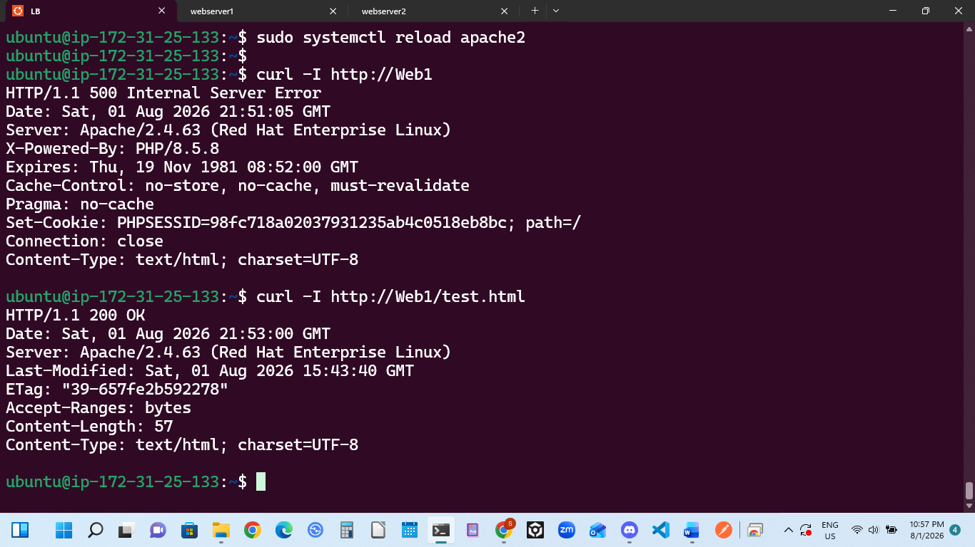

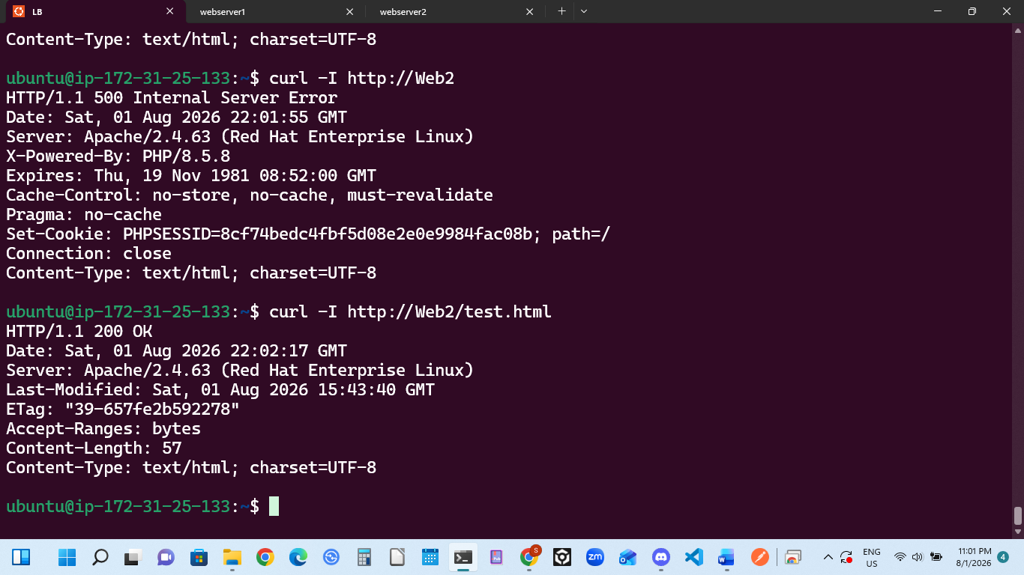

Your local DNS resolution configuration is 100% complete and working perfectly!
The curl -I http://Web1 command successfully reached your RHEL backend server. We know this because the response contains the signature header: Server: Apache/2.4.63 (Red Hat Enterprise Linux). If the /etc/hosts file had been misconfigured, the terminal would have thrown a Could not resolve host error instead.
The 500 Internal Server Error is completely normal in this exact context. When you run curl -I http://Web1 without specifying a file, it defaults to requesting the main root directory (/), which executes the index.php file. Since your Database instance is currently stopped to save your AWS budget, index.php crashes on the database handshake.
The HTTP/1.1 200 shows everything is OK.
This output officially proves everything works end-to-end:
- The local DNS name resolution (Web1) correctly resolves to your backend server.
- The Apache configuration cache is cleanly matching the virtual names.
- The server successfully fetches assets from your shared network NFS storage.

CONCLUSION
This project successfully demonstrates the deployment of a resilient Layer 7 Load Balancing solution using Apache HTTP Server to evenly distribute traffic across an isolated backend web cluster. By integrating a centralized NFS storage tier and configuring local DNS name resolution, the architecture optimizes data consistency and streamlines system manageability. Ultimately, resolving the localized path, permission, and runtime blockers provided critical real-world DevOps insights into building highly available, fault-tolerant infrastructure.

